**New Jersey Medical School**

**Department of Cell Biology and Molecular Medicine**

**Cardiovascular Research Institute**

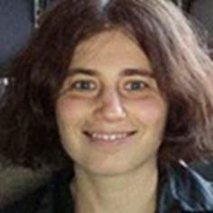

**Sophie Astrof, Ph.D.**

Philadelphia University & Thomas Jefferson University

Associate Professor

***“Mechanisms and roles of cell-ECM interactions during the development of the cardiac arterial pole”***

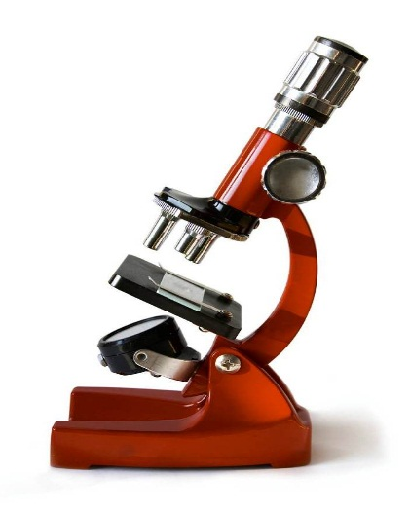

**Wednesday, November 29, 2017**

**11:00 a.m.**

**MSB G-609B**

**Host: Dr. Junichi Sadoshima, M.D., Ph.D.**