**New Jersey Medical School**

**Department of Cell Biology and Molecular Medicine**

**Cardiovascular Research Institute**

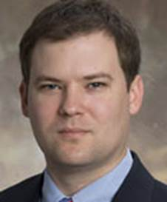

**John Calvert, M.D., Ph.D.**

Assistant Professor

Emory University School of Medicine

Department of Surgery

Division of Cardiothoracic Surgery

Carlyle Fraser Heart Center

***“Cardiac Actions of DJ-1”***

**Wednesday, May 23, 2018**

**11:00 a.m.**

**MSB G-609B**

**Host: Dr. Junichi Sadoshima, M.D., Ph.D.**