**New Jersey Medical School**

**Department of Cell Biology and Molecular Medicine**

**Cardiovascular Research Institute**

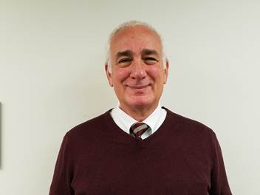

**Louis Dell’Italia, M.D.**

Associate Chief of Staff for Research

Birmingham VA Medical Center

Professor of Medicine, Pathology and Integrative and Cell Biology

University of Alabama at Birmingham

***“Multiple Mechanistic Facets of Cardiac Volume Overload”***

**Tuesday, October 31, 2017**

**1:00 p.m.**

**MSB G-609B**

**Host: Dr. Junichi Sadoshima, M.D., Ph.D.**