

**New Jersey Medical School**

**Department of Cell Biology and Molecular Medicine**

**Cardiovascular Research Institute**

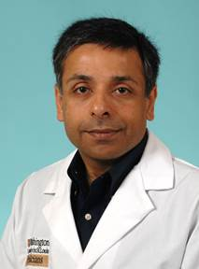

**Dr. Abhinav Diwan, MD, FACC, FAHA**

Associate Professor of Medicine

Cardiovascular Division

Department of Internal Medicine

Associate Professor of Cell Biology and Physiology

Staff Physician

Internal Medicine Service

VAMC

Washington University School of Medicine

*“****Harnessing the Lysosome Machinery to Prevent and Treat Diseases”***

Tuesday, November 8, 2016

1:30 p.m.

MSB G-609B