

**New Jersey Medical School**

**Department of Cell Biology and Molecular Medicine**

**Cardiovascular Research Institute**

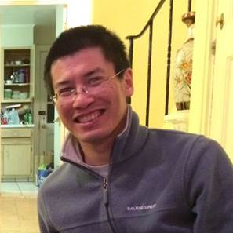

**Zhanpeng Huang, Ph.D.**

Harvard Medical School

Boston Children’s Hospital

Department of Cardiology