**New Jersey Medical School**

**Department of Cell Biology and Molecular Medicine**

**Cardiovascular Research Institute**

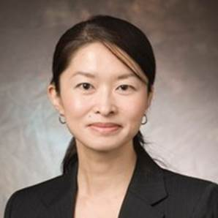

**Yasuko Iwakiri, Ph.D.**

**Associate Professor**

**Yale University School of Medicine**

**Internal Medicine/Digestive Diseases**

***“Hepatic blood flow and disease dynamics”***

**Wednesday, April 25, 2018**

**11:00 a.m.**

**MSB G-609B**

**Host: Dr. Junichi Sadoshima, M.D., Ph.D.**