**New Jersey Medical School**

**Department of Cell Biology and Molecular Medicine**

**Cardiovascular Research Institute**

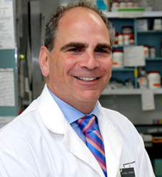

**Lorrie A. Kirshenbaum, Ph.D.**

Canada Research Chair in Molecular Cardiology  
Director of Research Development, Faculty of Medicine

Principal Investigator, Cardiac Gene Biology  
Institute of Cardiovascular Sciences

St. Boniface General Hospital Research Centre

University of Manitoba

***“Molecular Regulation of Autophagy and Cell Death: You only live Twice”***

**Monday, December 5, 2016**

**1:00 p.m.**

**MSB G-609B**

**Host: Dr. Junichi Sadoshima, M.D., Ph.D.**