**New Jersey Medical School**

**Department of Cell Biology and Molecular Medicine**

**Cardiovascular Research Institute**

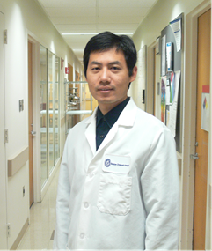

**Zhiqiang Lin, Ph.D.**

Instructor

Department of Cardiology

Children’s Hospital Enders

Harvard Medical School

***“Hippo pathway transcriptional effectors regulation of metabolism and cardiac repair”***

**Wednesday, January 24, 2018**

**11:00 a.m.**

**MSB G-609B**

**Host: Dr. Junichi Sadoshima, M.D., Ph.D.**