**New Jersey Medical School**

**Department of Cell Biology and Molecular Medicine**

**Cardiovascular Research Institute**

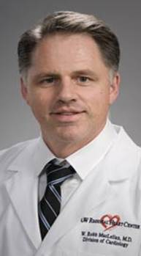

**William Robb MacLellan, MD**

University of Washington

Professor of Medicine and Head

Division of Cardiology

***“Epigenetic regulation of cardiac myocyte division: How to Grow a New Heart”***

Tuesday, November 17, 2015

2:00 p.m.

MSB G-609B