

**New Jersey Medical School**

**Department of Cell Biology and Molecular Medicine**

**Cardiovascular Research Institute**

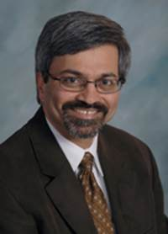

**Sumanth Prabhu, M.D.**

Professor of Medicine and Cell, Developmental, and Integrative Biology

Director, Division of Cardiovascular Disease

Mary G. Waters Chair of Cardiovascular Medicine

University of Alabama at Birmingham

***“Molecular Regulation of Autophagy and Cell Death: You only live Twice”***

**Wednesday, April 12, 2017**

**11:00 a.m.**

**MSB G-609B**

**Host: Dr. Junichi Sadoshima, M.D., Ph.D.**