**New Jersey Medical School**

**Department of Cell Biology and Molecular Medicine**

**Cardiovascular Research Institute**

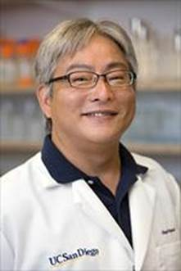

**Miyamoto Shigeki, Ph.D.**

University of California San Diego

Pharmacology

Associate Professor

***“Regulation of mitochondrial autophagy by depolarization independent intracellular signaling pathways; Hexokinase-II and RhoA”***

Wednesday, September 14, 2016

11:00 a.m.

MSB G-609B