**New Jersey Medical School**

**Department of Cell Biology and Molecular Medicine**

**Cardiovascular Research Institute**

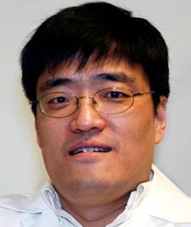

**Bin Zhou, M.D., Ph.D.**

Tenured Professor

Department of Genetics, and Pediatrics, Medicine Cardiology

Albert Einstein College of Medicine

***“Heart development and disease, an outlook from the endocardium”***

**Wednesday, July 18, 2018**

**11:00 a.m.**

**MSB G-609B**

**Host: Dr. Junichi Sadoshima, M.D., Ph.D.**