**New Jersey Medical School**

**Department of Cell Biology and Molecular Medicine**

**Cardiovascular Research Institute**

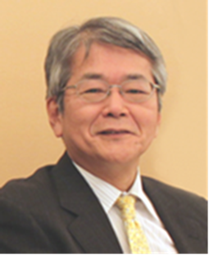

**Minoru Horie, M.D.,Ph.D.**

**Professor Emeritus**

**Shiga University of Medical Science**

***“Forty Years Study on Ion Channel Structure and Function, and its Disorders”***

**Monday, May 14, 2018**

**12:00 Noon**

**MSB G-609B**

**Host: Dr. Lai-Hua Xie, Ph.D.**