**New Jersey Medical School**

**Department of Cell Biology and Molecular Medicine**

**Cardiovascular Research Institute**

**Dr.** **Il-man Kim**

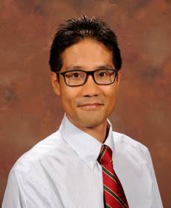

Associate Professor

Vascular Biology Center & Department of Biochemistry and Molecular Biology

Medical College of Georgia

College of Graduate School

Augusta University

***“Beta-arrestin-mediated adrenergic receptor signaling and non-coding RNAs in heart failure”***

    Wednesday, January 18, 2017

11:00 a.m.

MSB G-609B