DEPARTMENT OF PSYCHIATRY

Grand Rounds & Lecture Series

Same - Sex Intimate Partner Violence and HIV

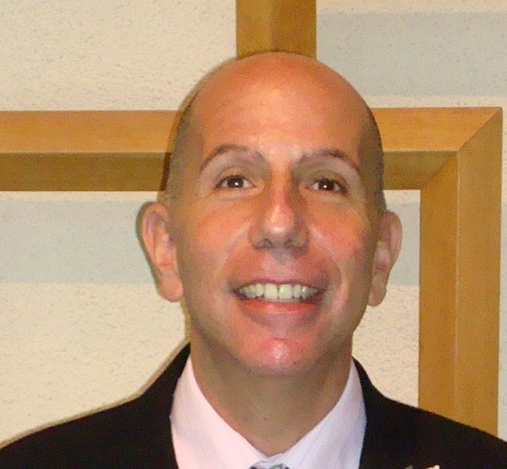

James Feinberg, LCSW Ch.t
Clinical Director
Opioid Treatment Program for the Addiction Institute of New York
St. Luke’s Roosevelt Hospital
New York, NY

Friday, Sep 20, 2013, 11:00 am - 12:30 pm

Medical Sciences Building, Room B-610

Objectives: At the conclusion of this program the participants should be able to:
- Assess for same sex intimate partner violence
- Identify similarities and differences of same sex intimate partner violence
- Identify barriers of same sex intimate partner violence

Disclosure Declaration:
- James Feinberg, LCSW CH.t has no relevant financial relationships and will not discuss an unapproved/uninvestigated use of a commercial product.
- Jacob Lindenthal, PhD, DrPH, Rashi Aggarwal, MD, Cheryl Kennedy, MD, Najeeb Hussain, MD, Tolga Taneli, MD (planner, committee members) have no relevant financial relationships.

Accreditation: UMDNJ Center for Continuing and Outreach Education is accredited by the Accreditation Council for Continuing Medical Education to provide continuing education for physicians, and designates this live activity for a maximum of 1.5 AMA PRA Category 1 Credit(s)™. Physicians should claim only the credit commensurate with the extent of their participation in the activity.

Sponsorship and Target Audience: This program is sponsored by the UMDNJ-NJMS Department of Psychiatry and the UMDNJ Center for Continuing and Outreach Education; it will be of interest to counselors, nurses, physicians, psychologists, researchers, social workers, students, and trainees.

