DEPARTMENT OF PSYCHIATRY

Grand Rounds & Lecture Series

Brain Imaging in Mood Disorders

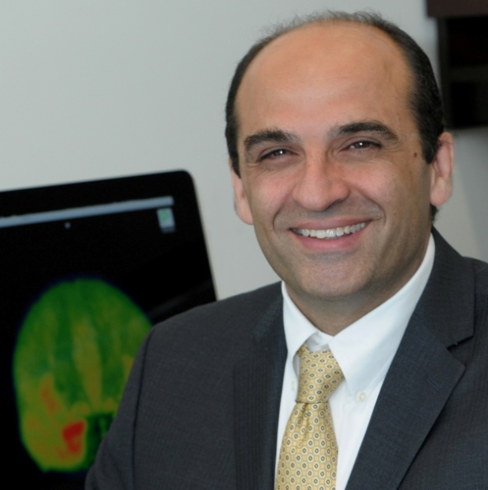

Ramin Parsey, MD, PhD
Professor and Chairman,
Department of Psychiatry and Behavioral Science
Stony Brook University School of Medicine
New York, NY

Friday, Oct 18, 2013, 11:00 am - 12:30 pm

Medical Sciences Building, Room B-610, Newark, NJ

Objectives: At the conclusion of this program the participants should be able to:
- Understand the role of PET imaging in psychiatric research.
- Understand the role of the serotonin 1A receptor in depression.
- Understand the role of the serotonin transporter in depression and suicidal behavior.
- Understand the role of multimodal imaging in psychiatric research.

Disclosure Declaration:
- Ramin Parsey, MD, PhD has no relevant financial relationship and will not discuss an unapproved/uninvestigated use of a commercial product in his presentation.
- Jacob Lindenthal, PhD, DrPH, Rashi Aggarwal, MD, Cheryl Kennedy, MD, Najeeb Hussain, MD, Tolga Taneli, MD, as members of the planning committee, have no relevant financial relationships.

Accreditation: Rutgers, The State university of New Jersey is accredited by the Accreditation Council for Continuing Medical Education to provide continuing education for physicians.
Rutgers, The State University of New Jersey designates this live activity for a maximum of 1.5 AMA PRA Category 1 Credit(s)™. Physicians should claim only the credit commensurate with the extent of their participation in the activity.

Sponsorship: This program is sponsored by Rutgers New Jersey Medical School Department of Psychiatry and Center for Continuing and Outreach Education at Rutgers Biomedical and Health Sciences.

Target Audience:

This program will be of interest to psychiatrists, psychologists, counselors, nurses, physicians, researchers, social workers, students, and trainees.

