**New Jersey Medical School**

**Department of Cell Biology and Molecular Medicine**

**Cardiovascular Research Institute**

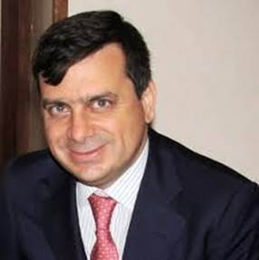

**Gianluigi Condorelli, MD, PhD**

Professor of Cardiology Humanitas University

Head, Department of Cardiovascular Medicine

Humanitas Research Hospital

***“Epigenetic control of myocardial function”***

**Thursday, July 12, 2018**

**11:00 a.m.**

**MSB G-609B**

**Host: Dr. Junichi Sadoshima, M.D., Ph.D.**