**New Jersey Medical School**

**Department of Cell Biology and Molecular Medicine**

**Cardiovascular Research Institute**

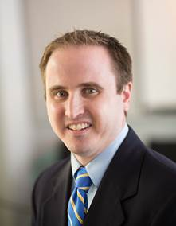

**Mark Kohr, Ph.D., FAHA**

**Assistant Professor**

**Department of Environmental Health and Engineering**

**Bloomberg School of Public Health**

**Johns Hopkins University**

***“S-nitrosylation and ischemia-reperfusion injury: new insights from the female heart”***

**Wednesday, April 11, 2018**

**11:00 a.m.**

**MSB G-609B**

**Host: Dr. Junichi Sadoshima, M.D., Ph.D.**