**New Jersey Medical School**

**Department of Cell Biology and Molecular Medicine**

**Cardiovascular Research Institute**

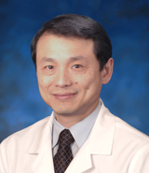

**Dr. Ping H. Wang**

Professor and Director

Department of Medicine

UCI Center for Diabetes Research and Treatment

Director, UC Irvine Health Diabetes Center

Chief, Division of Endocrinology, Diabetes and Metabolism

University of California

"Impaired Mitochondria Akt1 Signaling – A Mechanism for Diabetic Cardiomyopathy"

Tuesday, November 29, 2016

**1:00 p.m.**

#### MSB G-609B