

**New Jersey Medical School**

**Department of Cell Biology and Molecular Medicine**

**Cardiovascular Research Institute**

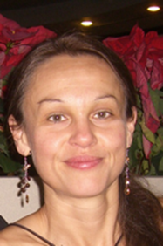

**Michelle D. Tallquist, Ph.D.**

***Associate Professor***

***Center for Cardiovascular Medicine***

***John A. Burns School of Medicine***

***University of Hawai‘i at Mānoa***

***“Cardiac fibroblast signaling pathways”***

**Wednesday, April 19, 2017**

**11:00 a.m.**

**MSB G-609B**

**Host: Dr. Junichi Sadoshima, M.D., Ph.D.**