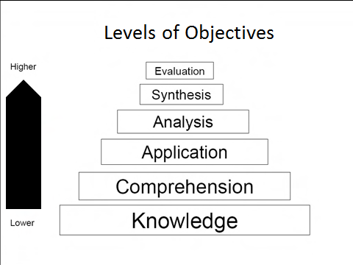
Learning Objectives:
- Are focused on what the learner will accomplish from the instruction/lecture.
- Are written in observable, behavioral terms, beginning with a descriptive verb
- Are used to organize and focus the learning content, determine engagements and activities, and to write test and exam questions.
How to Write Learning Objectives:
- Examine what you want the learner to be able to do/know from your content.
- Determine the level and complexity of the learning and select verbs that are associated with these (see Level of objectives above, and verb choices - other side)
- Write 3-5 objective statements of what the learner will do as a result of the learning.
EXAMPLES:
Well written objectives should complete this stem sentence and will demonstrate what the student has learned.
Upon completion of this lecture, you will be able to:
- List the key risk factors for dementia (Can you observe a student doing this? – Yes!)
- Describe the work-up (tests) that should be performed in diagnosing cognitive impairment (Can you observe a student doing this? – Yes!)
- Understand the purpose of performing an overall physical examination in order to diagnose a mental illness. (Can you observe a student doing this? – No! This is not an acceptable objective)
Vague, non-Measurable Objectives | Clear Behavioral/Learning Objectives
To know the motor, social and intellectual milestones in normal human development. | To describe the key motor, social and intellectual milestones in normal human development.
Know general morphology and overall differences between medulla, pons and midbrain. | Describe the differentiating characteristics and general morphology of the medulla, pons and midbrain.
Understand the symptoms of asthma. | Recognize the symptoms of asthma and use the appropriate treatments.

